

ICIMS
Integrated Church Information Management System
USER MANUAL
www.churchcentral.church
Prepared with reference to the ICIMS Product Profile
Publisher: Midas Management Concepts
Document version 1.0 - Draft for validation against the live ICIMS interface

HOW TO USE THIS MANUAL
Important note on sources
This manual is grounded in the official ICIMS Product Profile issued by Midas Management Concepts, which confirms ICIMS's modules, architecture, security model, and business model. The Product Profile does not include screen-by-screen interface documentation (exact button labels, field order, or menu paths). Wherever this manual describes a specific click-path, it is presented as a best-practice draft workflow, consistent with how systems of this kind are normally operated, and is marked for confirmation against the live platform. Administrators should validate each workflow the first time they use it and update the placeholders (screenshots, exact labels) before distributing this manual to end users.

Version | Date | Description | Author
1.0 | [Insert date] | Initial draft manual compiled from the ICIMS Product Profile | [Insert name]
1.1 | [Insert date] | Updated with verified screenshots and exact interface labels | [Insert name]

Conventions used in this manual
- Bold text refers to a button, menu item, or field name on screen (to be confirmed against the live interface).
- Numbered steps describe the recommended sequence of actions in a module.
- Grey dashed boxes mark a screenshot placeholder to be replaced with a live capture.
- Gold-bordered boxes highlight notes, warnings, or good-practice guidance.

TABLE OF CONTENTS
HOW TO USE THIS MANUAL 2
Conventions used in this manual 2
TABLE OF CONTENTS 3
1. WHAT IS ICIMS? 7
Core functional areas 7
Who should use ICIMS? 7
Understanding the ICIMS structure 8
Basic navigation 8
2. CREATING A MINISTRY ACCOUNT 10
Purpose 10
Who Can Use This Module 10
How to Navigate and Use It 10
Good Practice 11
Completing initial configuration 11
3. CREATING MINISTRY BRANCHES 11
3.1 What is a Ministry Branch? 11
3.2 Who Can Create a Branch? 11
3.3 When Should Branches Be Created? 12
3.4 How to Create a Ministry Branch 12
3.5 Reviewing Branches 13
4. CREATING A USER ACCOUNT USING THE MINISTRY LINK 14
Purpose 14
Who Can Use This Module 14
How to Navigate and Use It 14
Note to Adminstrators 14
5. INSTALLING ICIMS ON A DEVICE 15
Purpose 15
5.1 Installing on Android 15
5.2 Installing on iPhone or iPad 15
5.3 Desktop Access 15
6. TEAMS 16
What are Teams? 16
Who can use Teams 16
How to create a Team 16
Using Teams 16
7. REMINDERS 18
Purpose 18
Who can use Reminders 18
How to create a Reminder 18
Reminders are auto generated by the system from the data captured in the other modules, example Events, Date of birth, etc. 18
8. COMMUNICATION MODULE 18
Purpose 18
Who can use it 18
How communication works 18
How to send a communication? 18
Communication best practice 19
9. ATTENDANCE MODULE 20
Purpose 20
Who can use it 20
9.1 Manual Attendance 20
9.2 QR Check-In 20
10. EVENTS MODULE 22
Purpose 22
Who can use it 22
10.1 Creating an Event 22
10.2 Creating an Event Ticket 23
10.3 Generating and Sharing an Event Link 23
11. RESOURCES MODULE 25
What is the Resources Module? 25
Who can use it 25
How to create a Resource 25
12. GIVING MODULE 26
Purpose 26
Typical giving categories 26
12.1 Creating a Giving Campaign 26
12.2 Processing Giving 26
13. TRANSACTIONS MODULE 28
Purpose 28
Who Can Use This Module 28
How to Navigate and Use It 28
Good Practice 28
14. ROLES AND PERMISSIONS 29
Purpose 29
Suggested role structure 29
How to create or assign a role 29
15. PACKAGES 30
Purpose 30
What to review when choosing or changing a package 30
How to review a package 30
16. REPORTS 31
Purpose 31
Who can use Reports 31
How to generate a report 31
Recommended monthly management reports 31
17. SETTINGS 32
Purpose 32
Who can use it 32
Typical settings areas 32
Recommended procedure before changing a major setting 32
18. CHURCH WEBSITE 33
Purpose 33
Potential website content 33
Who can manage it 33
Recommended website workflow 33
Content management good practice 33
7. CELL MANAGEMENT MODULE 34
7.1 What is the Cell Management Module? 34
7.2 Who Can Use the Cell Management Module 34
7.3 Creating a Cell 34
7.4 Assigning Cell Members 35
7.5 Moving a Member Between Cells 36
7.6 Cell Meetings and Reporting 36
7.7 Cell Offering Through Giving Campaigns 37
7.8 Cell Dashboard 37
7.9 Cell Leadership Dashboard 38
7.10 Cell Reporting Cycle 39
7.11 Integration with Other ICIMS Modules 39
7.12 Recommended Cell Management Workflow 40
19. RECOMMENDED NEW MINISTRY SETUP SEQUENCE 41
Phase 1 — Establish the organisation 41
Phase 2 — Configure the structure 41
Phase 3 — Configure operations 41
Phase 4 — Go live 41
Phase 5 — Continuous management 41
20. DAILY OPERATING PROCEDURES BY ROLE 43
Church Administrator (daily) 43
Attendance Officer/Head Usher (per service) 43
Event Manager 43
Finance Officer (regularly) 43
21. TROUBLESHOOTING AND FREQUENTLY ASKED QUESTIONS 44
I cannot log in 44
I cannot see a module 44
I cannot see a branch 44
Attendance was recorded against the wrong event 44
A QR check-in does not work 44
A giving transaction appears incomplete 44
22. DATA SECURITY AND RESPONSIBLE USE 45
Users should: 45
23. USER SUPPORT 46

1. WHAT IS ICIMS?
ICIMS (Integrated Church Information Management System) is a cloud-based, scalable digital platform developed by Midas Management Concepts to support the operational, pastoral, financial, administrative and strategic functions of churches and ministry organisations.
The platform provides centralized management of church information and activities, promoting operational efficiency, accountability, secure data management, improved communication and informed decision-making. ICIMS integrates multiple church functions into a single secure digital environment, reducing duplication of effort and manual record-keeping.
ICIMS is modular and accessible from desktop computers, laptops, tablets and smartphones. Because it is modular, a ministry can activate the modules it needs according to its operational requirements and subscription package.

Core functional areas
- Membership management
- Giving management (online giving, pledges, transaction reporting)
- Events and programme management (scheduling, ticketing, attendance)
- Communication and notifications (email, push, targeted messaging, SMS/WhatsApp on demand)
- Attendance tracking and analytics
- Reporting and analytics (membership, financial, attendance, giving, growth)
- Resources library
- Roles, permissions and multi-level authorization
- Ministry settings and configuration
- Church website and digital ministry presence

Who should use ICIMS?
Access to ICIMS is controlled by role. Typical users include:
User | Typical Use
Senior Pastor / Church Leader | Strategic oversight, high-level reports
Church Administrator | Overall administration and configuration
Branch Administrator | Management of branch-level activities
Pastor | Member oversight and ministry engagement
Ministry Leader | Team and activity management
Team Leader | Coordination of an assigned team
Attendance Officer/Head Usher | Recording attendance and check-in
Event Manager | Creating and managing events and tickets
Finance Officer | Monitoring giving and transactions
Communications Officer | Sending messages and notifications
Member | Viewing information and participating in activities
System Administrator | Managing users, roles, permissions and configuration

Access is always governed by assigned roles and permissions. ICIMS supports unique user accounts, role-based permissions and multi-level authorization, so different users can be given different levels of access within the same ministry account.

Understanding the ICIMS structure
A typical ICIMS account is organised in a hierarchy:
Ministry
↓
Branches
↓
Teams / Groups
↓
Users and Members
↓
Activities: Attendance, Events, Giving, Communication, Reminders

The ministry account is the primary organisational account and owns the subscription. Branches represent physical or administrative locations. Teams organise people by department, ministry or function. Individual users and members sit inside branches and teams, and all day-to-day activity (attendance, events, giving, communication, reminders) is recorded against this structure.

Basic navigation
After signing in, users typically move through the following areas:
- Dashboard - overview of key activities and information.
- Main navigation menu - access to all enabled modules.
- Module workspace - the area for viewing and managing records within a module.
- Create / Add action - used to add a new record (member, event, reminder, etc.).
- Search and filters - used to locate existing records.
- Record details - used to view or edit a selected item.
- Profile / account area - personal account settings.
- Settings - ministry-level configuration, visible only to authorised users.
General navigation rule
For almost every module in ICIMS, the same pattern applies: Open Module → View Existing Records → Select or Create a Record → Complete Required Information → Save → Review. Learning this pattern once makes every other module easier to use.
Figure 1 - The ICIMS dashboard after sign-in

2. CREATING A MINISTRY ACCOUNT

Purpose
Creating a ministry account establishes the church or organisation as a registered entity within ICIMS. This is the first step for any new ministry, and creates the account under which branches, teams, users, and all subsequent activity will be organised. The person who creates the account normally becomes the ministry's initial administrator or account owner.

Who Can Use This Module
- Founder
- Senior Pastor
- Church Administrator
- Authorised ministry representative

How to Navigate and Use It
- Go to www.churchcentral.church in a web browser.
- Select “Start for free” or “Get Started”.
- Enter the ministry details requested - ministry name, ministry email, telephone number, country, location, administrator name, administrator email, and a password.
- The system will lead you to select your appropriate subscription package. Review the available subscription packages, compare included features and limits, and select the package appropriate to the ministry's size.
- Complete any account verification step (e.g. email confirmation).
- Sign in using the registered credentials.
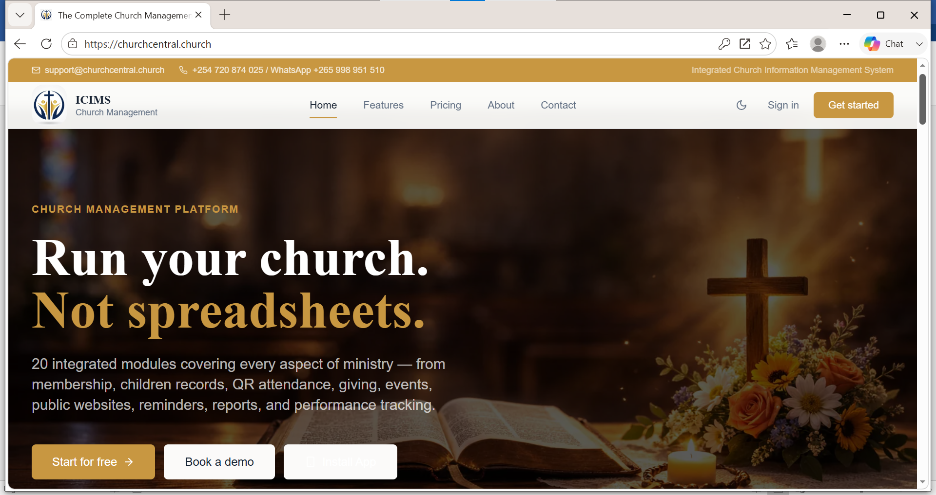
Figure 2 - Ministry registration and account confirmation screens

Good Practice
- Create branches before entering large volumes of members, teams, attendance or transaction data - this keeps reporting clean from day one.
- Assign at least one backup administrator so the ministry is never dependent on a single login.
- Record the registered administrator email and password securely; this account controls the whole ministry's ICIMS presence.

Completing initial configuration
Once the account is confirmed, the ministry administrator should:
- Review and complete the ministry profile.
- Configure core ministry settings.
- Create branches where the ministry has more than one location.
- Create teams.
- Invite or register users via the ministry link (see Section 3).
- Define roles and permissions.
- Configure communication and giving arrangements where applicable.

3. CREATING MINISTRY BRANCHES

3.1 What is a Ministry Branch?
A Ministry Branch represents a distinct church location or organisational unit operating under the main ministry account. The branch structure allows a ministry to organise activities and information according to location or organisational unit. For example, a ministry operating in Malawi may have:
- Main Branch - Lilongwe
- Blantyre Branch
- Mzuzu Branch
- Area 25 Branch
- Youth Branch
- Campus Branch

3.2 Who Can Create a Branch?
Branch creation should normally be restricted to users with appropriate administrative permissions, such as:
- Ministry Administrator
- Church Administrator
- Senior church leadership
- Other authorised system administrators

3.3 When Should Branches Be Created?
Branches should be established before significant operational data is entered into ICIMS. The recommended setup sequence is:
Create Ministry Account
↓
Create Ministry Branches
↓
Create / Assign Users
↓
Create Teams
↓
Configure Ministry Operations
↓
Start Recording Members, Attendance, Events and Transactions

This ensures information is correctly associated with the relevant branch from the outset.

3.4 How to Create a Ministry Branch
- Sign in - log in to the ICIMS ministry account using an authorised administrator account.
- Open Branch Management - from the main navigation menu, select Branches or the equivalent branch-management option.
- Select Create Branch - select Create Branch, Add Branch, or the applicable button displayed in the system.
- Enter branch information - typically branch name, branch location, physical address, contact telephone, email address, branch leader, branch description, and any other information requested by ICIMS.
- Assign the branch leader -the person responsible for administering or leading the branch.
- Save the branch - review the information and select Save/Create. The branch should now appear in the ministry's list of branches.
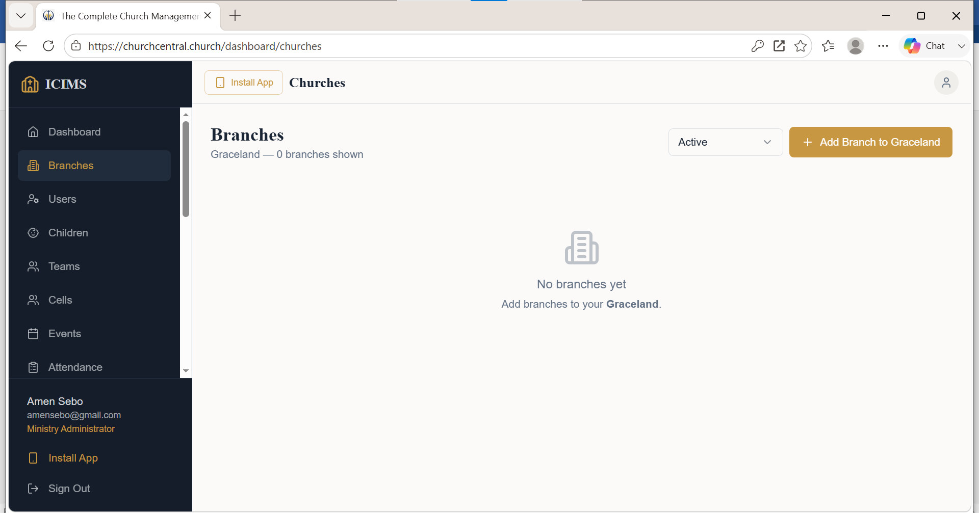
Figure 3 - Branch Management screen showing the Create/Add Branch option

3.5 Reviewing Branches
After creating a branch, the administrator should verify:
- Branch name
- Location
- Branch leader
- Contact information
- Assigned users
- Applicable permissions
Important administration principle
A branch does not automatically give every branch user access to the entire ministry's information. Access should be determined by the user's role and permissions. ICIMS is designed with role-based permissions and controlled administrative privileges, so a user assigned to one branch does not automatically see records belonging to another branch.

4. CREATING A USER ACCOUNT USING THE MINISTRY LINK

Purpose
The ministry link is a unique registration link generated by a ministry administrator that connects a new user's account directly to the correct branch of the ministry, without the user needing to search for or select the ministry manually. It is the recommended way to onboard members, workers, pastors, leaders and administrators.

Who Can Use This Module
- Members
- Church workers
- Pastors
- Ministry leaders
- Branch administrators
- Other authorised users

How to Navigate and Use It
- The ministry administrator generates or retrieves the ministry's registration link from within ICIMS.
- The link is shared with the intended user through WhatsApp, email, SMS, the church website, social media, a QR code, or printed materials. Links are specific to branches. Administrators should take care to avoid misposting links, especially where a network of branches is involved.
- The user opens the link on a smartphone, tablet or computer.
- The user completes the registration form - typically name, email address, mobile number, password and any other details the ministry requires.
- The user submits the form and completes any verification step.
- Once the account is active, the user signs in to ICIMS.
- The features visible to the user are determined by their assigned role, permissions, ministry configuration, and the ministry's subscription package.
🖼 SCREENSHOT PLACEHOLDER
Figure 3 - Ministry link registration form on a mobile device

Note to Administrators
- Periodically review new registrations for duplicate accounts.
- Regularly review users who have no role assigned.
- Deactivate accounts for members who are inactive or who should no longer have access.
- Keep the ministry link private to the appropriate audience if the ministry wants controlled registration (e.g. share only with confirmed members rather than posting publicly).

5. INSTALLING ICIMS ON A DEVICE

Purpose
ICIMS is a responsive, web-based platform optimised for both desktop and mobile access. The current version also supports installation as an app-like shortcut (Progressive Web App) for quicker access from a phone or tablet home screen.

5.1 Installing on Android
- Open a supported browser (e.g. Chrome).
- Visit www.churchcentral.church.
- Sign in to the ministry account.
- Open the browser menu.
- Select Install App or Add to Home Screen (or the equivalent option, if offered).
- Confirm the installation.
- Open ICIMS from the new home-screen icon in future.

5.2 Installing on iPhone or iPad
- Open the ICIMS website in Safari.
- Tap the Share button.
- Choose Add to Home Screen.
- Confirm the name for the shortcut.
- Tap Add.
- Open ICIMS from the Home Screen icon in future.

5.3 Desktop Access
- Open a supported web browser.
- Visit www.churchcentral.church.
- Sign in.
- Where the browser supports it, select the browser's install/shortcut option to pin ICIMS as a desktop app.
🖼 SCREENSHOT PLACEHOLDER
Figure 4 - Installing ICIMS on Android and iPhone home screens

6. TEAMS

What are Teams?
Teams let a ministry organise people into functional or ministry groups - for example Ushers, Choir, Media Team, Children's Ministry, Youth Ministry, Evangelism Team, Prayer Team, Finance Team, or Hospitality Team.

Who can use Teams
- Administrators
- Branch administrators
- Ministry leaders
- Team leaders (for their own team)

How to create a Team
- Navigate to the Teams section.
- Select Create Team / Add Team.
- Enter the team name, description, branch (where applicable) and team leader.
- Add members to the team.
- Save the team.

Using Teams
Once created, teams can be used to support:
- Targeted communication
- Team coordination
- Reminders
- Activity management
- Organisational reporting
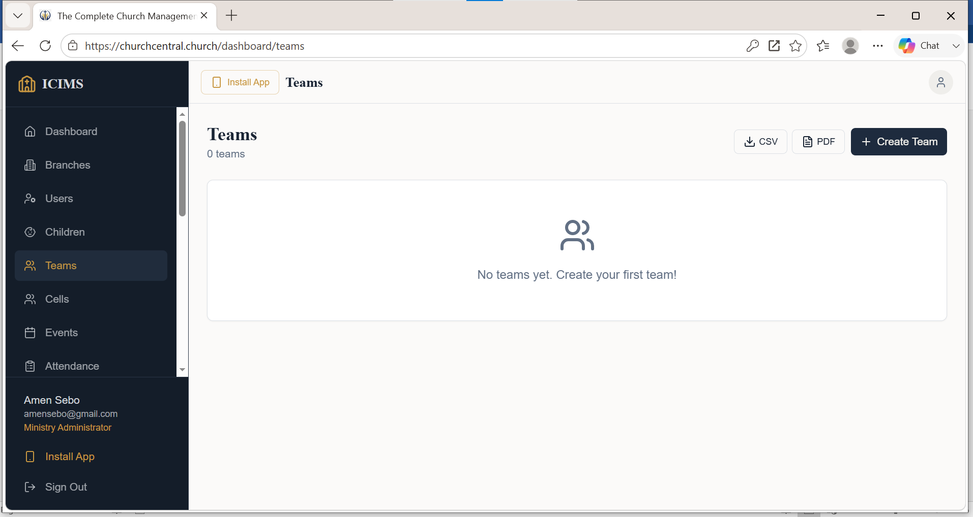
Figure 6 - Team list and Create Team form

7. REMINDERS

Purpose
Reminders help users and administrators track important tasks, milestones, and events.

Who can use Reminders
- Administrators
- Leaders
- Team leaders
- Other authorised users

How to create a Reminder

Reminders are auto generated by the system from the data captured in the other modules, example Events, Date of birth, etc.

8. COMMUNICATION MODULE

Purpose
The Communication module enables structured communication from ministry leadership to members. Confirmed capabilities include email communication, targeted communication, push notifications, and event alerts, with bulk SMS and WhatsApp integration available on demand.

Who can use it
- Ministry administrators
- Communications officers
- Pastors
- Authorised ministry leaders

How communication works
Select Audience → Create Message → Select Channel → Send / Schedule → Review Delivery

How to send a communication?
- Navigate to the Communication module.
- Select the option to create/compose a new message.
- Select recipients - for example all members, a branch, a team, event participants, or selected individuals.
- Choose the communication channel: email, push notification, event alert, or SMS/WhatsApp where configured.
- Prepare the message: title/subject, main content, call to action, and date/deadline where applicable.
- Review the recipient group, content, channel and timing.
- Send immediately, or schedule where the feature is available.

Communication best practice
Avoid sending every communication to every user. Target the right audience for each message:
Message | Recommended Audience
Choir rehearsal | Choir team only
Youth event | Youth team / members
Branch meeting | Relevant branch
Church-wide announcement | All members
Finance committee meeting | Finance team
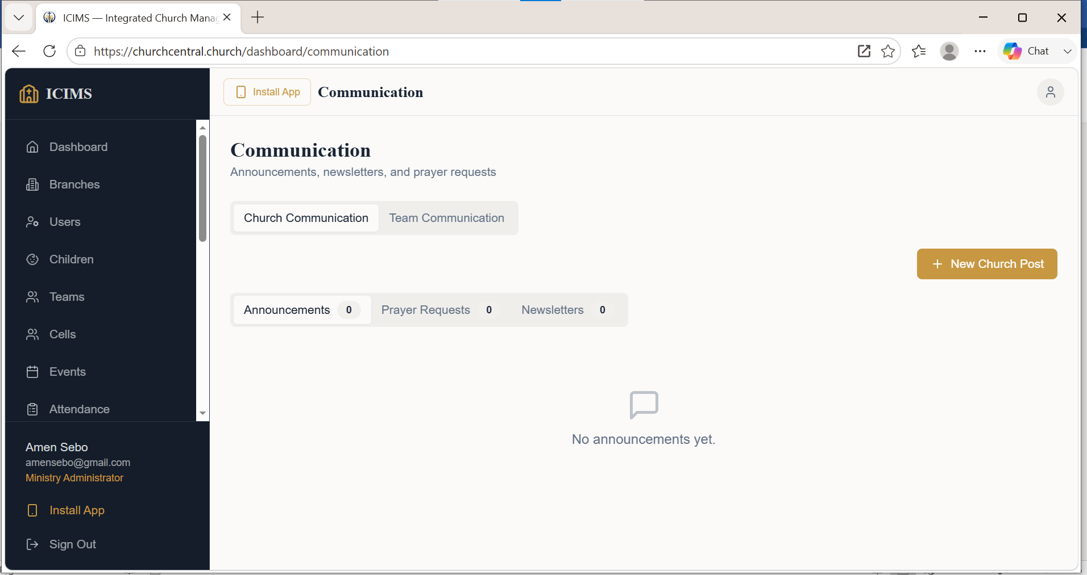
Figure 8 - Compose Message screen with audience and channel selection

9. ATTENDANCE MODULE

Purpose
The Attendance module records participation in services, meetings, events and other ministry activities, and supports attendance analytics as part of the wider reporting capability of the platform.

Who can use it
- Attendance officers / head ushers
- Branch administrators
- Team leaders
- Event managers
- Other authorised personnel

9.1 Manual Attendance
- Navigate to the Attendance module.
- Select the relevant service, event, meeting or programme.
- Confirm the date and branch where applicable.
- Search for a person by name or other registered identifier.
- Mark the person as present.
- Repeat for all attendees.
- Review and save the attendance record.
Recommended procedure for large services
Prepare attendance officers before the service, assign registration/check-in points, use QR check-in where available, keep manual check-in as a fallback, and reconcile all records after the service.

9.2 QR Check-In
QR check-in provides a faster method of recording attendance. The general process is:
Generate/Display QR Code → Attendee Scans Code → ICIMS Records Check-In → Attendance Record Updated

How to use QR check-in
- Open the attendance or event check-in function for the relevant service or event.
- Generate or display the applicable QR code.
- Instruct participants to scan the code using the approved ICIMS check-in process.
- Confirm successful registration on screen.
- Monitor the attendance list for exceptions.
- Use manual attendance for anyone unable to check in electronically.
To be verified
The Product Profile confirms attendance tracking and attendance analytics as platform capabilities, but does not document the exact QR generation and scanning screens. This workflow should be confirmed against the live production interface before being finalised for end users.
🖼 SCREENSHOT PLACEHOLDER
Figure 9 - QR check-in: event selection, QR display, and scan confirmation

10. EVENTS MODULE

Purpose
The Events module supports planning and administration of church programmes and events, including event scheduling, event ticketing, programme attendance tracking, and event reporting. Typical events include Sunday services, conferences, crusades, youth camps, seminars, training programmes, prayer meetings, leadership meetings, and fundraising events.

Who can use it
- Event managers
- Ministry leaders
- Branch administrators
- Ministry administrators

10.1 Creating an Event
- Navigate to the Events module.
- Select Create Event / Add Event.
- Enter the basic details: event name, description, start/end date, start/end time, venue or online location, branch, organising team, and event image where supported.
- Configure registration where required: enable registration, set capacity, define registration conditions, and configure tickets where applicable.
- Review the information and save/publish the event.
- Before publicising the event, test the registration process, confirm the date/time, confirm ticket configuration, and confirm the public event link.
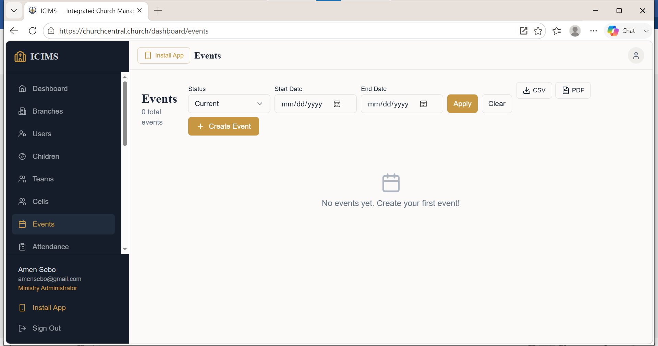
Figure 10 - Create Event form

10.2 Creating an Event Ticket
Event tickets are used where participation requires controlled registration, ticket allocation, or paid entry. Typical ticket types include General Admission, VIP, Pastor/Minister, Student, Early Bird, and Free Registration.
- Open the relevant event.
- Navigate to Tickets (or the ticketing section).
- Create a ticket type.
- Configure the ticket: name, price, quantity available, sales/registration opening date, closing date, and any conditions.
- Save the ticket.
- Test the registration process end to end.
Good practice
If an event has different participation categories, create separate ticket types instead of using a single general ticket, so registration numbers and revenue can be tracked by category.
🖼 SCREENSHOT PLACEHOLDER
Figure 11 - Ticket configuration screen

10.3 Generating and Sharing an Event Link
The event link lets the ministry promote an event outside ICIMS - for example through WhatsApp, Facebook, Instagram, email, the church website, SMS, or printed QR codes.
- Open the event.
- Confirm that the event is published.
- Locate the event's public or sharing link.
- Copy the link.
- Test the link in a browser.
- Share the link through the ministry's approved publicity channels.
Before sharing, confirm that:
- The event title, date and venue are correct.
- Registration is active where required.
- Tickets are available where applicable.
- The public event information is complete.
🖼 SCREENSHOT PLACEHOLDER
Figure 12 - Event public link and share options

11. RESOURCES MODULE

What is the Resources Module?
The Resources module organises and provides access to ministry materials and digital resources - for example Bible study materials, sermon notes, training manuals, policy documents, leadership guides, ministry forms, audio and video resources, links, and downloads.

Who can use it
- Administrators
- Pastors
- Ministry leaders
- Content managers
- Members with access rights

How to create a Resource
- Open Resources.
- Select Create Resource / Add Resource.
- Choose the resource type, where applicable.
- Enter the resource title, description, category, relevant ministry/team, and access level.
- Upload or link the resource.
- Set access permissions.
- Save or publish.
Good practice - naming resources clearly
Use specific, descriptive titles rather than generic ones. Instead of “Training Document”, use something like “New Believers Discipleship Guide - Module 1”, so members and leaders can find the right material quickly.
🖼 SCREENSHOT PLACEHOLDER
Figure 13 - Resources library and Add Resource form

12. GIVING MODULE

Purpose
The Giving module supports church financial stewardship and digital giving. Confirmed functions include online giving of offerings, tithes and partnerships, pledge and pledge tracking, transaction reporting, and personal acknowledgement of giving.

Typical giving categories
- Tithe
- Offering
- Partnership
- Building Fund
- Missions
- Special Seed
- Welfare
- Event Contribution

12.1 Creating a Giving Campaign
- Navigate to the Giving module.
- Open the Campaigns area.
- Select Create Campaign.
- Enter campaign details: name, purpose, description, target amount (where applicable), start date, end date, giving category, and campaign image/publicity material where supported.
- Configure the payment/giving options available to the ministry.
- Review and publish/activate the campaign.
Example campaign
Campaign: Church Building Expansion 2027. Purpose: Construction of new children's ministry classrooms. Target: [Ministry-defined target]. Duration: January-December 2027.
🖼 SCREENSHOT PLACEHOLDER
Figure 14 - Create Giving Campaign form

12.2 Processing Giving
Select Campaign/Category → Enter Amount → Select Payment Method → Confirm Giving → Payment Processing → Transaction Recorded → Acknowledgement (where configured)

User procedure
- Open Giving.
- Select the relevant giving category or campaign.
- Enter the giving amount.
- Provide any other required information.
- Select the available payment method.
- Review the amount.
- Confirm the transaction.
- Wait for the payment result.
- Retain the acknowledgement or reference number.

Finance administration
Authorised finance users should regularly monitor:
- Successful transactions
- Pending transactions
- Failed transactions
- Reconciliations
- Giving by campaign
- Giving trends
🖼 SCREENSHOT PLACEHOLDER
Figure 15 - Giving screen with payment method selection

13. TRANSACTIONS MODULE

Purpose
The Transactions module provides a record of the financial transactions processed through ICIMS. It is closely linked to the Giving module's transaction reporting and to the platform's broader reporting and analytics capability.

Who Can Use This Module
- Finance officers
- Finance managers
- Senior administrators
- Auditors or other authorised reviewers

How to Navigate and Use It
- Open Transactions.
- Select the required period.
- Apply filters where available (e.g. branch, campaign, payment status).
- Review the transaction list.
- Open a transaction for full details.
- Verify the status and reference information.
- Export or report where permitted by your role.
🖼 SCREENSHOT PLACEHOLDER
Figure 16 - Transactions list with filters and detail view

Good Practice
Do not alter or delete financial records unless the ministry's approved financial controls permit the action and your assigned permissions allow it. ICIMS maintains audit records relating to financial transactions and other system activities, so unauthorised changes are traceable.

14. ROLES AND PERMISSIONS

Purpose
Roles control what users can access and what actions they can perform. ICIMS confirms role-based access control, role-based permissions, and multi-level authorization as part of its security architecture.

Suggested role structure
Role | Typical Authority
Super / Ministry Administrator | Full ministry administration
Church Administrator | Operational administration
Branch Administrator | Branch-level administration
Finance Officer | Giving and transaction functions
Communications Officer | Communication functions
Event Manager | Events and ticketing
Attendance Officer/Head Usher | Attendance / check-in
Team Leader | Assigned team management
Pastor / Leader | Assigned pastoral oversight
Member | Personal / member-level access

How to create or assign a role
- Open Roles or User Management.
- Create a new role, or select an existing one.
- Define the permissions for that role.
- Save the role.
- Select the user who needs the role.
- Assign the appropriate role to the user.
- Confirm the user's access reflects the assigned role.
Principle of least privilege
Users should receive only the permissions required to perform their duties - no more. Review role assignments periodically and remove access that is no longer needed.
🖼 SCREENSHOT PLACEHOLDER
Figure 17 - Roles and Permissions screen

15. PACKAGES

Purpose
Packages determine the subscription arrangement and the features or capacity available to a ministry. ICIMS is delivered on a Software as a Service (SaaS) model, with subscription-based, annual licensing, institution-specific customised, and scalable multi-branch deployment arrangements available.

What to review when choosing or changing a package
- Number of users
- Number of branches
- Required modules
- Event requirements
- Communication requirements
- Reporting needs
- Support requirements

How to review a package
- Open the Packages or Subscription area.
- View the current package.
- Review the available features included.
- Review any usage limits.
- Review upgrade options.
- Contact the authorised ICIMS support channel if a package change is required.
To be completed before publication
The exact package names, pricing tiers and feature allocations are commercial details that change over time. Insert the current commercial configuration here before distributing this manual to end users.

16. REPORTS

Purpose
Reports convert ministry data into information for operational and strategic decision-making. Confirmed reporting capabilities include membership statistics, financial summaries, attendance analytics, ministry performance reports, event participation reports, giving trends analysis, and growth dashboards.

Who can use Reports
- Senior leadership
- Administrators
- Finance officers
- Branch leaders
- Ministry leaders

How to generate a report
- Open Reports.
- Select the report category.
- Select the reporting period.
- Select branch, team or other filters where applicable.
- Generate the report.
- Review the results.
- Export, print or share where the system permits.

Recommended monthly management reports
Area | Suggested Metrics
Membership | Total registered members; new members; growth trends
Attendance | Service attendance; event attendance; branch attendance trends
Giving | Giving by category; giving by campaign; giving trends
Events | Registrations; participation; ticket activity
🖼 SCREENSHOT PLACEHOLDER
Figure 18 - Reports dashboard

17. SETTINGS

Purpose
Settings provide the central configuration area for ministry-level system information.

Who can use it
- Ministry administrator
- Other users specifically authorised to manage configuration

Typical settings areas
- Ministry profile
- Contact information
- Branch configuration
- Roles and permissions
- Communication configuration
- Giving/payment configuration
- Website configuration
- User management
- Subscription/package information

Recommended procedure before changing a major setting
- Confirm the purpose of the change.
- Confirm you have the authority to make it.
- Review the current setting.
- Make the change.
- Save.
- Test the affected function.
Handle with care
Avoid unnecessary changes to user permissions, payment settings, ministry identity information, and public website settings - these affect the whole ministry and are harder to reverse.
🖼 SCREENSHOT PLACEHOLDER
Figure 19 - Settings overview screen

18. CHURCH WEBSITE

Purpose
The Church Website function gives the ministry a public digital presence connected to its wider ICIMS ecosystem, supporting online engagement and digital ministry activities.

Potential website content
- Ministry information and About the Church
- Leadership information
- Branches
- Events and event registration
- Giving opportunities and campaigns
- Resources
- Contact information

Who can manage it
- Ministry administrator
- Communications officer
- Website / content administrator

Recommended website workflow
Create Content → Review Content → Publish → Test Public View → Share Public Link

Content management good practice
Every public page should be:
- Accurate and current
- Consistent with ministry branding
- Free from spelling errors
- Reviewed before publication
🖼 SCREENSHOT PLACEHOLDER
Figure 20 - Church website content management screen

19. CELL MANAGEMENT MODULE

19.1 What is the Cell Management Module?
The Cell Management module enables a church to organise, manage and monitor its cells (small groups) within ICIMS. A cell is a small fellowship group that meets regularly for fellowship, Bible study, prayer, evangelism, member care, discipleship, follow-up, ministry development, and giving and financial participation.
The module gives church leadership a structured way of knowing which cells exist, who belongs to each cell, who leads them, when they meet, what happens in their meetings, and how each cell is progressing. It is designed as more than a membership list - it supports a continuous management cycle:
Create Cell → Assign Members → Hold Cell Meeting → Record Meeting → Record Attendance → Give Cell Offering → Monitor Cell Dashboard

19.2 Who Can Use the Cell Management Module
Access should be determined by the user's role and permissions.
User | Typical Function
Senior Pastor | Overall cell ministry oversight
Ministry Administrator | Create and administer cells
Cell Ministry Coordinator | Manage cells and cell leaders
Branch Administrator | Manage cells within a branch
Cell Leader | Manage assigned cell and submit reports
Assistant Cell Leader | Support cell administration
Cell Member | View / participate in assigned cell activities
System Administrator | Configure access and permissions

ICIMS uses role-based permissions and controlled administrative privileges, so cell-level access should be restricted according to responsibility, in the same way as every other module.

19.3 Creating a Cell
- Sign in to ICIMS and select Cell Management from the main navigation menu. The dashboard should display the cells accessible to the current user.
- Select Create Cell / Add Cell to open the cell registration form.
- Enter the cell details: cell name, cell leader, assistant cell leader, meeting day, meeting time, cell address/location, description, and status.
- Assign the cell leader - the leader should preferably already have a registered ICIMS user account, so the system can associate them with the cell and grant the functions permitted by their role.
- Review the information and select Save/Create Cell. The cell should now appear in the list of cells.

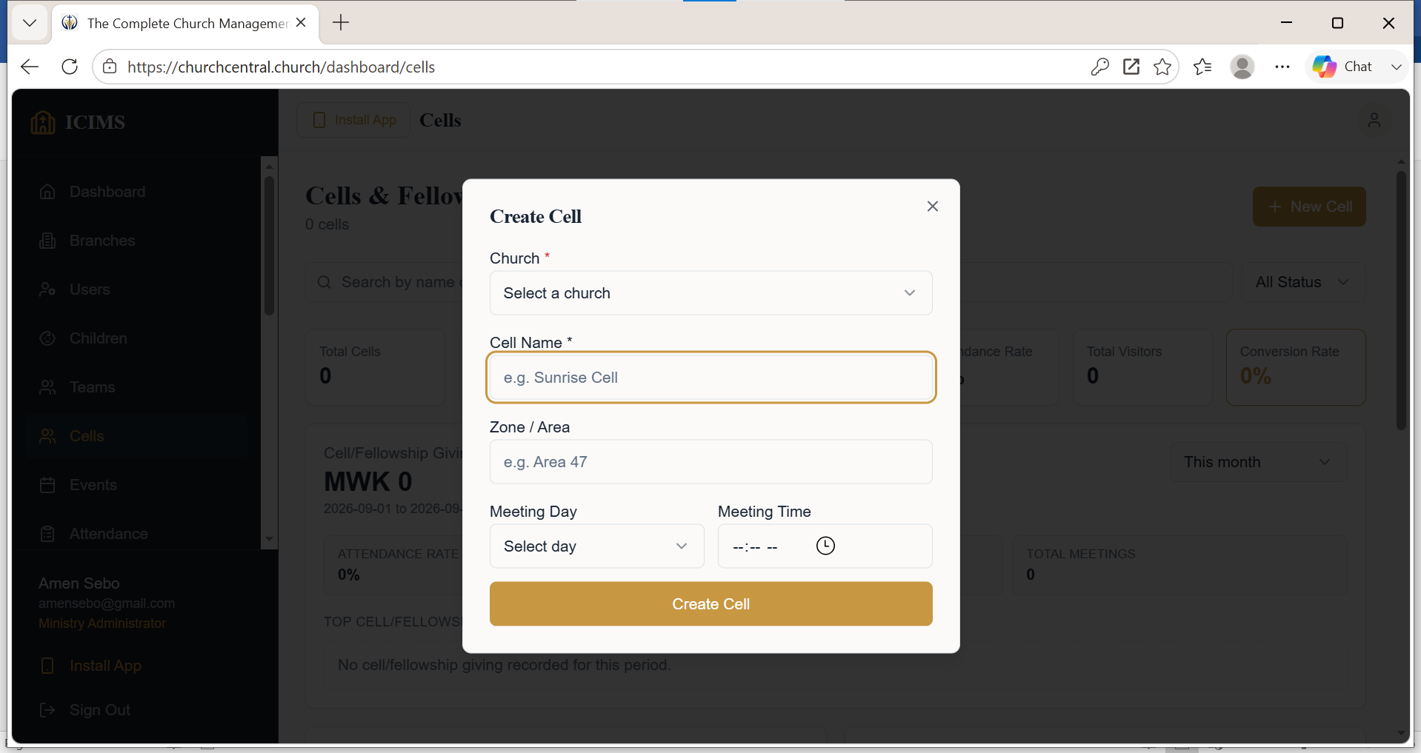

19.4 Assigning Cell Members
After creating a cell, the administrator must populate it with members. This establishes the relationship: Member → Cell → Cell Leader → Branch.
- Open the relevant cell from the Cell Management list.
- Select Members / Add Members / Manage Members.
- Search the existing ICIMS membership database by name, telephone number, email, or membership identifier - this avoids creating duplicate member records.
- Select the appropriate person from the search results.
- Add the selected person to the cell, and repeat for every member who belongs to the cell.
- Review the resulting cell membership list.
A cell profile should ideally show:
- Cell leader and assistant leader
- Number of members
- Member names
- Contact information where authorised
- Active/inactive membership status

19.5 Moving a Member Between Cells
Members may move between cells because of a change of residence, a change of branch, family circumstances, ministry restructuring, cell multiplication, or discipleship progression. The authorised administrator should:
- Open the member's record or the cell membership list.
- Select the member.
- Select the option to change/transfer cell.
- Select the new cell.
- Confirm the transfer.
- Review the member's new cell assignment.
The system should preserve the member's historical information where possible.

19.6 Cell Meetings and Reporting
The module should record not simply that a meeting occurred, but what happened during the meeting. The typical workflow is:
Cell → Meeting → Attendance → Offering → Report

How to report a cell meeting
- Open the relevant cell and select Cell Meetings.
- Select Report Meeting / Add Meeting Report.
- Create a meeting entry by clicking “+Meeting”. Enter the meeting date and theme.
- Record attendance for members who attended - by clicking “Present, Absent, Excuse” against each cell member.
- Record the ministry activities undertaken during the meeting, such as Bible study, prayer, evangelism, follow-up, member counselling, outreach, welfare/support, or discipleship.
- Review the information and select Submit / Save Meeting Report. The report becomes available to authorised church leadership and cell ministry coordinators.
Example meeting report
Cell: Area 25 Growth Cell. Date: 2 September 2026. Active members: 15. Present: 12. Visitors: 2. Topic: Faith and Christian Growth. New Convert: 1. Offering: MK 25,000.
Consistently recorded meeting reports allow the church to monitor attendance rate, regular attendees, members frequently absent, visitors, and overall cell participation trends.

19.7 Cell Offering Through Giving Campaigns
The Cell Management module is integrated with the Giving Campaigns functionality rather than creating a separate financial mechanism, so cell offerings are processed through the same secure giving infrastructure as other church giving.
Create Cell Offering Campaign → Share Giving Link → Cell Members Give → Transaction Recorded → Cell Rinancial Reports Updated

How cell members give
Cell Members give through their mobile Apps- Giving, select Cell/Fellowship Offering, indicate the amount to give, select how to give and enter the security PIN when prompted. Ensure you receive a notification of the giving. Where notification is not received, escalate the issue to the cell leader for further redress.
How to give your cell offering
- Select the cell offering campaign.
- Select your cell name
- Enter the amount.
- Provide any required information.
- Select the payment method.
- Confirm the payment.
- Receive the transaction acknowledgement, where configured.

19.8 Cell Dashboard
The Cell Dashboard gives a quick overview of the health and performance of an individual cell, bringing together the information that would otherwise require checking several separate reports.
Recommended dashboard components:
- Cell profile - name, branch, cell leader, assistant leader, meeting location/schedule, status.
- Membership - total members, active members, new members, visitors, members added in the period.
- Attendance - latest meeting attendance, average attendance, attendance percentage, trend, frequently absent members.
- Meetings - meetings held, meetings missed, last meeting, next meeting, meeting frequency.
- Giving - latest cell offering, total offering for the period, and giving trend (visible only to users with appropriate financial permissions).

Example cell dashboard
Indicator | Current
Cell Members | 15
Active Members | 13
Last Meeting Attendance | 12
Average Attendance | 11
Visitors | 2
New Converts | 1
Meetings This Month | 4
Cell Offering | MK 85,000

Leadership can use the dashboard to classify each cell, for example:
- Healthy cell - consistent meetings, strong attendance and member engagement.
- Cell requiring attention - declining attendance or irregular meetings.
- Cell requiring intervention - inactive meetings, very low attendance, or leadership problems.
🖼 SCREENSHOT PLACEHOLDER
Figure 10 - Cell Dashboard (or recommended dashboard design, if not yet built in the live system)

19.9 Cell Leadership Dashboard
At branch or church level, the Cell Ministry Coordinator is able to see an aggregated picture across all cells, for example:
Indicator | Branch Total
Total Cells | 20
Active Cells | 18
Total Cell Members | 285
Average Attendance | 78%
Meetings Held | 72
New Members | 14
Visitors | 21
Cell Offering | MK 1,250,000

This creates a Cell Ministry Performance Dashboard that pastors and administrators can use for oversight and planning.

19.10 Integration with Other ICIMS Modules
The Cell Management module is integrated with the wider ICIMS ecosystem rather than operate in isolation:
ICIMS Module | Cell Integration
Membership | Identifies and manages cell members
Branches | Associates cells with branches
Teams | Can support cell leadership structures
Attendance | Records cell meeting participation
Reminders | Reminds leaders about meetings and follow-up
Communication | Communicates with cell members
Events | Promotes and manages cell-related events
Giving | Processes cell offerings through campaigns
Transactions | Records giving transactions
Reports | Produces cell performance reports
Roles | Controls access to cell information
This is consistent with the overall ICIMS architecture, which integrates church functions into a centralized environment and reduces duplication of administrative work.

20. DASHBOARD MODULE

Purpose
The Dashboard is the daily landing page for users after login. It gives a quick view of ministry activity, recent records, urgent notices, package status, and shortcuts to common actions.

Who can use it
Ministry administrators
Branch administrators
Team and cell leaders
Members, where their role permits dashboard access

How to use it
Review the summary cards at the top of the page.
Open recent activity items that need attention.
Use the sidebar to move into modules such as Attendance, Giving, Cells, Events, or Reports.
If a module is hidden, confirm the user's role permissions and package features.

Good practice
Use the Dashboard as a daily health check. If numbers look unexpected, open the source module and review the underlying records before making decisions.

21. USERS MANAGEMENT MODULE

Purpose
Users Management helps authorised administrators manage people who can sign in to ICIMS, including staff, leaders, workers, members, and other ministry users.

Common user tasks
Create or invite a user.
Assign the correct role and branch.
Search, filter, and review user details.
Update user profile information where permitted.
Deactivate users who should no longer access the system.

Role and permission guidance
A user's access is controlled by their assigned role, their church or ministry scope, and the package features available to the ministry. Give users only the access they need for their responsibility.

Good practice
Keep email addresses and phone numbers accurate because they are used for communication, password recovery, finance workflows, and reporting.

22. CHILDREN MODULE

Purpose
The Children module records children or dependants connected to church members and families. It supports safer child ministry administration and helps leaders understand children by age, gender, guardian, branch, and participation.

Who can use it
Children ministry administrators
Branch administrators
Ministry administrators
Other authorised users

How to use it
Open Children from the sidebar.
Add a child record with name, gender, date of birth or age, guardian details, and branch.
Link the child to a parent or guardian where available.
Use filters and exports to review children by branch, age group, or guardian.

Good practice
Children's information is sensitive. Only authorised workers should access it, and exported lists should be handled carefully.

23. PLEDGES MODULE

Purpose
The Pledges module helps members and administrators track giving commitments against giving campaigns, including promised amount, amount redeemed or paid, outstanding balance, deadline, and pledge status.

Member workflow
Open Pledges or a giving campaign that allows pledging.
Create a pledge with the amount and deadline.
Review personal pledges and outstanding balances.
Make or record payments against the pledge where available.

Administrator workflow
Review ministry pledges by campaign, church, status, and date.
Record manual pledge payments when cash, bank, or mobile money is received outside online checkout.
Use pledge reports to see one person per campaign with pledged, paid, and outstanding totals.

Good practice
Use pledge statuses to follow up responsibly. A partial pledge means some amount has been redeemed, while fulfilled means the pledge has been fully paid.

24. WALLETS AND WITHDRAWALS MODULE

Purpose
Wallets show collected funds available through ICIMS finance flows. Withdrawals allow authorised finance users to request payment from available wallet balances.

Wallet concepts
Church wallet: balance connected to a specific branch or church.
Ministry wallet: total view of balances available across the ministry's churches.
Available balance: amount that may be withdrawn after system checks.
Pending withdrawal: a withdrawal request that has been created and is awaiting processing or final confirmation.

Withdrawal workflow
Open Withdrawals.
Select Request Withdrawal.
Enter withdrawal details such as amount, method, bank or mobile money details.
Review whether the amount is within the allowed range.
Request and enter the OTP code.
Submit the request and monitor the withdrawal status.

Good practice
Only authorised finance users should request withdrawals. Confirm recipient details carefully before submitting because finance actions affect ministry funds.

25. PERFORMANCE DASHBOARD

Purpose
The Performance dashboard brings together ministry indicators such as attendance, giving, membership growth, events, and other key metrics for leadership review.

How to use it
Open Performance from the sidebar.
Choose the reporting period or available filters.
Review trends and summary cards.
Use related Reports for exportable records and detailed analysis.

Good practice
Use performance trends together with source records. If a trend looks wrong, verify the underlying attendance, giving, membership, or event data.

26. PUBLIC LINKS AND QR CODES

Purpose
Public links and QR codes allow people to interact with ICIMS without needing full dashboard access. They support event registration, giving, attendance entry, scanner check-in, and public church pages.

Common public links
Event links for registration or ticket booking.
Giving links for public donations and campaign contributions.
Attendance links for shared attendance entry.
Scanner links for authorised check-in flows.
Church website links for public ministry information.

Good practice
Share only active links. If a link should no longer be used, revoke it or close the related record where the module allows it.

27. PACKAGE PAYMENTS AND INVOICES

Purpose
Package payments and invoices help ministries manage subscription payments for their ICIMS package. The visible package price, currency, and payment method depend on the ministry's country or assigned pricing market, unless the ministry has a private/custom package.

How package payment works
Open Packages from the sidebar.
Review the active package, included features, limits, and available package options.
Choose the billing period where available.
Proceed to payment or use the invoice link provided by ICIMS.
After successful payment, the subscription period is updated.

Good practice
Confirm the package, billing period, and total amount before paying. Package payments are separate from giving, event tickets, and other ministry collections.

28. REPORT TYPES AND EXPORTS

Purpose
Reports provide exportable records and summaries for ministry administration, finance review, follow-up, and leadership decision-making.

Common report types
Membership reports for member lists and filters.
Attendance reports for service, event, and cell participation.
Giving reports by transaction, campaign, member, and cell/fellowship offering.
Pledge reports showing one person per campaign with pledged, paid, and outstanding totals.
Visitor reports showing unique visitors for follow-up, including first visit and return visit columns.
Cell group reports showing cell leaders, members, meetings, visitors, attendance, giving, and conversion information.
Transaction reports for financial record review.

Good practice
Always apply the correct church, cell, campaign, category, and date filters before exporting. Reports should be used for authorised ministry work only.

29. PAYMENT METHODS AND FINANCE SETUP

Purpose
ICIMS supports online and manual payment workflows depending on the country, package, module, and configured payment provider. Finance setup controls whether online payments can be processed for giving, tickets, packages, and related flows.

User-facing concepts
Online payment: payment made through the checkout link.
Manual payment: cash, bank, mobile money, or other payment recorded by an authorised user.
Finance account or subaccount: payment setup connected to a church or ministry so collections can be routed correctly.
Payment status: shows whether a payment is pending, completed, failed, or requires review.

Good practice
Before publishing paid events or online giving campaigns, confirm that the correct finance account is configured and that test payments or checks have been completed where required.

30. RECOMMENDED NEW MINISTRY SETUP SEQUENCE
A new ministry should implement ICIMS in the following order:

Phase 1 - Establish the organisation
- Create the ministry account.
- Verify the account.
- Select a package.
- Complete the ministry profile.

Phase 2 - Configure the structure
- Create branches.
- Create teams.
- Create roles.
- Assign authorised users.

Phase 3 - Configure operations
- Configure communication.
- Configure reminders.
- Configure attendance procedures.
- Configure events.
- Configure giving where applicable.
- Configure resources.

Phase 4 - Go live
- Invite users through the ministry link.
- Train administrators.
- Conduct a pilot service/event.
- Test manual attendance.
- Test QR check-in.
- Test communication.
- Test reporting.

Phase 5 - Continuous management
- Review reports.
- Monitor user access.
- Review transaction records.
- Update website and public information.
- Maintain data quality.

31. DAILY OPERATING PROCEDURES BY ROLE

Church Administrator (daily)
- Review notifications.
- Review reminders.
- Check important communications.
- Monitor registrations.
- Resolve administrative issues.

Attendance Officer/Head Usher (per service)
- Select the correct service/event.
- Open check-in.
- Facilitate QR check-in.
- Record exceptions manually.
- Review attendance totals.

Event Manager
Before an event:
- Confirm event information.
- Confirm registration.
- Confirm tickets.
- Test the event link.
- Share the publicity link.
After an event:
- Review participation.
- Close registrations if necessary.
- Generate attendance/event reports.

Finance Officer (regularly)
- Review transactions.
- Monitor campaign performance.
- Reconcile records according to the church's financial procedures.
- Generate financial reports.

32. TROUBLESHOOTING AND FREQUENTLY ASKED QUESTIONS

I cannot log in
Check the following:
- Email/username entered correctly.
- Password entered correctly.
- Internet connection is active.
- You are using the correct ministry link/platform.
- Your account is active.
If necessary, use the password reset process.

I cannot see a module
Possible causes:
- The module is not included in the ministry's current package.
- Your role does not have permission for that module.
- The feature has not been enabled by the ministry administrator.
Contact your ministry administrator if the issue persists.

I cannot see a branch
- Check whether the branch has been created.
- Check whether you have been assigned to it.
- Check whether your permissions allow access to it.

Attendance was recorded against the wrong event
The correction should be performed by an authorised administrator following the ministry's data-correction procedures - do not attempt to alter records outside your assigned permissions.

A QR check-in does not work
- Check internet connectivity.
- Confirm the correct event/service is selected.
- Confirm the QR code is valid.
- Confirm the event/check-in period is active.
Use manual attendance as a controlled fallback.

A giving transaction appears incomplete
Do not assume a payment was successful simply because an attempt was initiated. Review the transaction status and payment reference in the Transactions module before confirming the giving record.

33. DATA SECURITY AND RESPONSIBLE USE
ICIMS uses authentication and access-control mechanisms including unique user accounts, strong password controls, role-based permissions and multi-level authorization, alongside secure data transmission and protected payment integrations.

Users should:
- Never share passwords.
- Log out of shared or public devices after use.
- Use strong, unique passwords.
- Avoid giving unnecessary access to others.
- Review user roles periodically.
- Protect member information at all times.
- Use only authorised payment and communication configurations.
Data ownership
All church data entered into ICIMS remains the property of the client church. Backup, technical support and maintenance arrangements are provided as part of the platform's SaaS delivery.

34. USER SUPPORT
For platform support, contact ICIMS through:
Channel | Detail
Website | www.churchcentral.church
Email | support@churchcentral.church
Phone | +254 720 874 025
WhatsApp | +265 998 951 510

Before publishing this manual
Replace every screenshot placeholder with a live capture from the current ICIMS interface, confirm every bolded button/menu label against the production system, and insert the ministry's current package names and pricing where indicated in Section 15. Once verified, this document becomes the ministry's authoritative ICIMS user manual.

